**An Open Educational Resource (OER) Learning Management System for Sustainability and Environment Studies**

Digital Media Design Capstone

Masters of Liberal Arts Degree

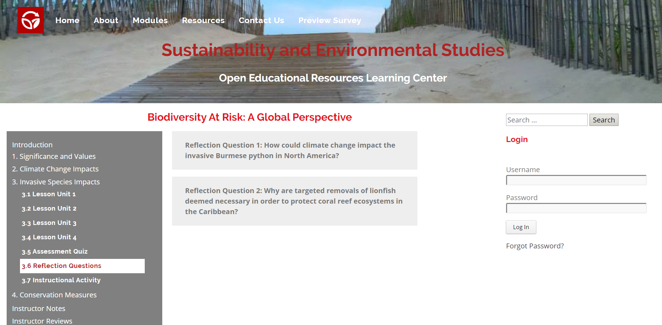

Harvard University

Extension School

May 3, 2020

John F. Reilly

**Table of Contents**

Abstract 1

1. Introduction 2

2. Technology Components….. 2

3. Technology Requirements and Workflow….. 3

4. Prototype Development 6

5. Work Plan and Milestones 7

6. Building the Learning Management System 8

7. Demonstrative Product 9

8. Final Product 9

9. Summary and Conclusions 10

10. Future Plans 10

11. Project Repository 10

References .11

**Abstract**

Notes to Write-up:

. Identity problem with existing on-line education

. LMS purpose to fill this gap

. Summarize assessment criteria to build the LMS

. Summarize conclusions

**1. Introduction**

The fundamental purpose of the Learning Management System (LMS) is to bridge the gap between existing eLearning resources which are often too general and not focused on what environmental students need to learn in order to achieve the desired educational outcomes. Since students are more likely to use an e-Learning platform if it was initially assigned, instructors in Sustainability and Environmental Studies, then, are the primary target audience for the LMS who would wish to supplement their own teachings with the learning modules. The learning material is not supposed to be introductory or replace textbooks or lectures, but rather to complement instructor teachings by delving deeper into Sustainability and Environmental Studies topics and issues. The LMS further differs from existing eLearning offerings by using an Understanding by Design approach advocated by Grant Wiggins and Jay McTighe. Key principles of this approach include using hooks, chunking, and repetition, having a big idea, addressing misunderstandings, and promoting enduring understandings (Wiggins and McTighe, 2005).

**2. Technology Components**

**2.1 WordPress Content Management System**

WordPress is a popular content management system which includes a database, a template system, and a plugin architecture. WordPress provides many of the required features of the LMS as well as a built-in database to house the instructional content. A key feature of the LMS is the ability of instructors to edit content with only basic knowledge of the content management system. WordPress was the best content choice due to its popularity and user-friendliness.

**2.2 Custom CSS**

CSS programming along with JavaScript was needed to tailor the user experience of the WordPress platform into the custom LMS needed to meet the project requirements.

**2.3. Custom JavaScript**

Custom JavaScript programming was required to develop the more advanced features of the LMS such as a collapsible menu system and a responsive design which would be very difficult to achieve solely through the limited capabilities of the included features in WordPress.

**2.4. Custom WordPress Plugins**

WordPress plugins are small software applications which can extend the functionality of WordPress. The following plugins were used for this Capstone project:

. BackWPup – WordPress Backup Utility

. Code Embed – Embed JavaScript and HTML code in posts and pages

. Contact Form 7 – Create Contact Forms

. Duplicate Page – Duplicate Posts, Pages and Custom Posts

. Embed Google Map – Create Google Maps

. HD Quiz – Create Quizzes

. Header and Footer Scripts – Allows insertion of JavaScript Coding

. PDF Embedder – Embeds PDF into Posts and Pages

. Sidebar Login Widget – Sidebar Widget Used to Log into WordPress Account

. User Access Manager – Manage access to Posts, Pages, Categories and Files

**3. Technology Requirements and Workflow**

The Learning Management System was developed as an eLearning website using the WordPress content management system with HTML5 Blank as the active theme. This minimalistic theme allows the user experience to be fully realized with custom CSS and JavaScript programming as well as the selection of a few key WordPress Plugins. Here is the website map:

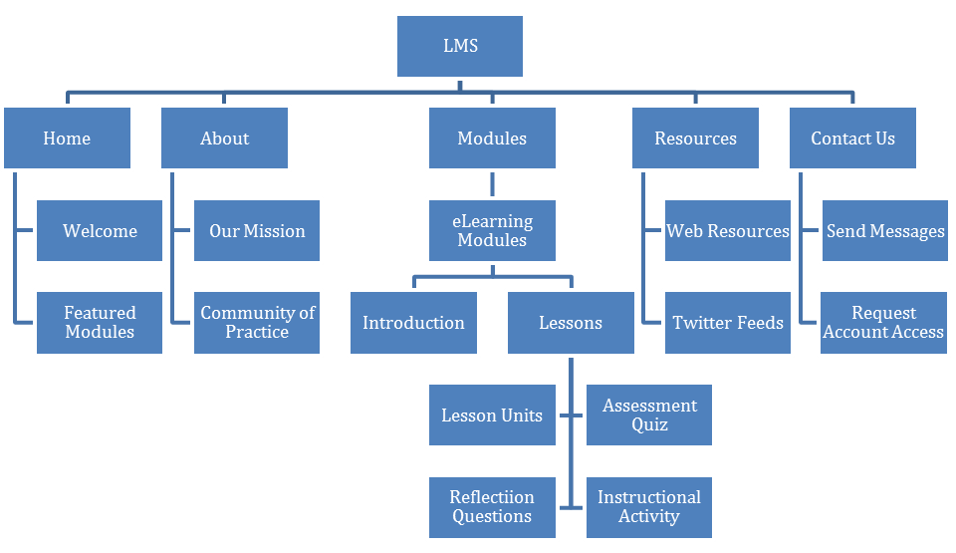

With the instructional content being maintained in a WordPress database, instructors will be able to easily create their own learning modules, lessons, or activities with only basic WordPress knowledge. The instructional design of the LMS will adhere to an Understanding by Design approach. The key Understanding by Design techniques deployed include using hooks, chunking, and repetition, having a big idea, addressing misunderstandings, and promoting enduring understandings (Wiggins and McTighe, 2005).

**Understanding by Design Planning**

|  |  |
| --- | --- |
| High-Level Overview. Briefly describe your learning experience, including the type of learning experience, intended audience, duration, etc. Use the Instructional Design Mad Lib to assist you. | |
| The LMS will offer Sustainability and Environmental Studies eLearning modules to instructors who wish to supplement their own teachings. The instructional content will be curated using an Understanding By Design approach. | |
| Content Topic: Identify the content topic that will be explored. Though broad, this is often where instructional designers begin. | Big Idea: Keep in mind the misunderstanding or gap, and identify the big idea, a ***concept*** about this topic that is worth knowing and can be applied to other content/contexts. It provides a unifying and thoughtful way to focus the design of the project. The big idea should be expressed in a few words. |
| Open Educational Resources for students in Sustainability and Environmental Studies | Align eLearning resources for students in Sustainability and Environmental Studies. |
| Misunderstanding or Gap: Think about the prior experiences, knowledge, and mindset of the learners. What might they misunderstand about this topic or what is a gap in their thinking/experience that prevents them from understanding this topic and/or big idea? This may be informed by any combination of research, observation, or interviewing. | |
| Existing eLearning resources are too general and do not hone in on what students need to learn. | |

|  |  |
| --- | --- |
| 6 Facets of Understanding: The 6 facets are a tool to help unpack what deep learning looks like. Not all facets are applicable for all projects; however, consider each one. What could a possible desired understanding or learning outcome be through the lens of each of the six facets? Share your notes here. | |
| Explanation: Really gets at explaining something in the learner’s own words  Students will understand how short, interactive lessons can be more engaging than text based assignments. | Perspective: Gets at what it means to see the big picture or consider various points of view  Students will understand how interactive learning allows students to learn at their own pace. |
| Interpretation: How to make sense of something  Students will understand that there are multiple ways to learn the same skill. | Empathy: Asks the learner to “walk in another’s shoes”  Students will understand that one way of learning may be more effective for some students than others. |
| Application: Matches knowledge to context  Students will understand how eLearning resources can provide better access to suitable web resources. | Self-Knowledge: Gets learners to think about their own thinking  Students will understand that they learn better when they are more focused and engaged. |
| Why/Enduring Understanding(s): Frame your big idea as 1–2 understanding statements. The understanding statement is expressed as a full-sentence statement and represents an insight, inference, or conclusion about the big idea that learners should gain. Rather than the facts you want them to learn, the understanding statement looks to the meaning of the facts. | |
| Students will understand that Open Educational Resources can be aligned to match their needs in Sustainability and Environmental Studies. | |

|  |
| --- |
| Evidence of Understanding: How will you know that your learners have obtained the desired understanding? This is often thought of as assessment in formal learning environments. For self-paced and informal learning experiences, this may be more difficult to identify but try. |
| The LMS will provide assessment quizzes and reflection questions as well as instructional activities for collaborative problem solving. |

|  |
| --- |
| Learning Flow: What is the general flow of the learning experience? You may provide a bulleted high-level list, create a Journey Map (a timeline that graphically maps the experience), or other graphic organizer. |
| The LMS will offer instructional learning modules to supplement instructor teachings. Each module will comprise of an introduction to capture the student’s attention and several lessons reinforcing the big idea and helping to achieve enduring understandings. Each lesson with be comprised of lesson units, an assessment quiz, reflective questions, and an instructional activity. |

|  |  |
| --- | --- |
| Learning Theories: What learning theories—the way in which how people learn—will your learning experience draw upon? List them and make sure you research them further to see how they inform the approach you’ll take. | Pedagogies: What pedagogies—methods of how people teach—will your learning experience draw upon? List them and share why. |
| . Backward Design Model– Following the Understanding by Design Approach, the instructional content will be designed to achieve specific learning goals.  . Problem Based Learning – Instructional activities will be designed for student groups to solve a challenging problem. | . Blended Learning – The instructional content will supplement instructor teachings.  . Active Learning – Students will be engaged in the learning process through reflective questions and instructional activities.  . Collaborative Learning – Students will work collaboratively on instructional activities. |
| Inspiration: Identify at least three other learning experiences/products that inspire your project, e.g., workshop, training, e-learning course, game, curriculum, museum exhibit, YouTube channel, etc. Be specific. | |
| . Crystal Bridges Museum of American Art online learning courses  . LinkedIn Learning  . Managing eLearning Projects from elearningindustry.com | |

**4. Prototype Development**

In the Instructional Design Studio course(Harvard University Extension School EDUC E-113) during the spring of 2019, student and instructor interviews were conducted in order to assess their Sustainability and Environmental Studies learning experiences. Three key educational outcomes were identified:

. Short, interactive lessons are more engaging than text.

. Blended learning allows students to proceed at their own pace.

. Offering multiple ways to teach the same skill is more engaging for students.

While eLearning can help achieve these outcomes, the availability of suitable Open Educational Resources in Sustainability and Environmental Studies is very limited. Furthermore, existing eLearning resources are often too general and do not hone in on what environmental students need to learn. This Capstone’s Learning Management System, then, is specifically designed to address these issues by bridging this gap.

**5. Work Plan and Milestones**

With the prototype completed in the spring of 2019, the Learning Management System was developed as a complete application in the Capstone Design Studio course(Harvard University Extension School DGMD-599) during the spring of 2020 according to the following work plan:

|  |  |  |
| --- | --- | --- |
| Milestone | Completion | Deliverable Description |
| Finalize the System Design | February 10 | Finalize the design of the Learning Management System and curate the first 20% of the instructional content. |
| Complete the User Interface | March 2 | Complete the user interface for the LMS and curate the next 20% of the instructional content. |
| Provide Community of Practice Access for Instructors | March 23 | Provide instructors with secured access to post reviews on the learning modules, lessons, and activities and curate the next 20% of the instructional content. |
| Provide Community of Practice Access for Contributors | April 13 | Provide contributors with secured access to update and create learning modules, lessons, and activities and curate the next 20% of the instructional content. |
| Complete the System | May 4 | Complete the development of the LMS and curate the final 20% of the instructional content. |

**6. Building the Learning Management System**

Notes to Write-up:

. Marketing and Needs Analysis completed in spring of 2019 through interviews and competitor reviews.

. Prototype was a proof of concept.

. Final design including technology complete in fall of 2019 – Pre-Capstone Course

. LMS developed with 5 assessment criteria. Briefly discuss each.

**Assessment Rubric**

|  |  |  |  |  |  |
| --- | --- | --- | --- | --- | --- |
| Criteria/Metrics | Inadequate  1 | Marginal  2 | Fair  3 | Good  4 | Exceptional  5 |
| **Learning Design:** Well-structured, interesting and engaging instructional content which supports enduring understandings. | Few conditions are met and enduring understandings are not supported. | Conditions are partially met and enduring understandings are partially supported. | Conditions are mostly met and enduring understandings are generally supported. | Conditions are met and enduring understandings are mostly supported. | Conditions are well met and enduring understandings are strongly supported. |
| **User Engagement:** Instructors will recognize that the LMS can be used to supplement their teachings. | Instructors find little value in assigning any of the lessons to their students. | Instructors find some value in assigning only a few lessons to their students. | Instructors find value in assigning some of the lessons to their students. | Instructors find strong value in assigning some of the lessons to their students. | Instructors find strong value in assigning many of the lessons to their students. |
| **Application:** Clearly demonstrates the capabilities of the Learning Management System. | Few of the capabilities of the learning experience are apparent. | Some of the capabilities of the learning experience are apparent. | Many of the capabilities of the learning experience are apparent. | Many of the capabilities of the learning experience are very apparent. | Most of the capabilities of the learning experience are very apparent. |
| **Presentation:** Clear and consistent professional-looking layout to garner interest in the Learning Management System. | Layout appears amateurish and garners little interest. | Layout appears somewhat professional and garners some interest. | Layout appears mostly professional and generally interesting. | Layout appears professional and appealing. | Layout appears very professional and very appealing. |
| **Adaptability:** Suitable for use in other educational and professional training applications. | Adaptability for other applications is not apparent. | Adaptability for other applications would require many changes. | Adaptability for other applications would require some changes. | Adaptability for other applications is apparent with few changes. | Adaptability for other applications is apparent with no changes. |

**7. Demonstrative Product**

Although the project focus is to curate a Learning Management System to supplement programs in Sustainability and Environmental Studies, the System itself should not be limited to that particular field of study. Rather, the LMS should be developed so its capabilities are independent of the content. In this regard, the Capstone can be treated as a demonstration of the LMS for use in other educational and professional training applications.

**8. Final Product**

Notes to Write-up:

. With 4 modules and a total of 16 lessons, LMS already has more than a semester’s worth of instructional content.

. Instructional content for demonstrative product were from my ALM in Sustainability and Environmental Studies

. Instructional Content will need to be tailored to the needs of the actual instructors

. Does not need to be limited to Sustainability and Environmental Studies as can be tailored to practically any discipline.

**9. Summary and Conclusions**

Notes to Write-up:

. Current on-line offerings are limited and ineffective

. Demand for one-line education will continue to grow rapidly

. Instructional content needs to be supportive of instructor’s teachings

. Instructional content needs to be tailored to instructor’s needs

. LMS needs to deploy teaching methods to capture and maintain student attention and focus on enduring understandings.

**10. Future Plans**

Notes to Write-up:

. Write up project for an educational publication.

. Look for Educational partner like Harvard Extension School to complete final production and launch the LMS.

**11. Project Repository**

The Learning Management System with all of the coding, data, and instructional content is directly hosted in WordPress in a siteground.com web account at<http://johnr1.sgedu.site/wp/>. The custom JavaScript coding, custom CSS styling, images, menus, and instructional content pdfs have been extracted to a GitHub repository at <https://github.com/jreillyHES/Capstone>.

**References**

Arshavskiy, M. (2014). Managing e-Learning Projects. *Elearning Industry*.

URL: <https://elearningindustry.com/managing-e-learning-projects>.

BBC. (2014). Your Guide to Environmental Studies Learning Resources and Online Courses. *BBC.*

URL: <http://www.bbc.co.uk/learning/subjects/environmental_studies.shtml>.

Bean, C. (2014). *The Accidental Instructional Designer: Learning Design for the Digital Age.*

Brandon, B. (2004). Closing the Loop in e-Learning Development: How to Reconnect Instructional Design and Project Management. *Learning Solutions Magazine*.

URL: <http://www.learningsolutionsmag.com/articles/283/closing-the-loop-in-e-learning-development-how-to-reconnect-instructional-design-and-project-management>.

Coursera. (2019). From Courses to Degrees. URL: <https://www.coursera.org/>.

CrystalBridges. (2017). Online Learning. Crystal Bridges Museum of American Art.

URL: <https://crystalbridges.org/online-learning/>

Growth Engineering. (2019). The Learning Portal – A Simple Idea that Made the World Better. URL: <https://www.growthengineering.co.uk/learning-portal/>.

Humboldt. (2019). Open Educational Resources (OER) Environment Science & Management, *Humboldt State University*.

URL: <https://libguides.humboldt.edu/openedu/emp>.

Khan Academy. (2019). Ecology.

URL: <https://www.khanacademy.org/science/biology/ecology>.

Rand-Hendriksen, M. (2019). WordPress 5 Essential Training. *Lynda.com*.

URL: <https://www.lynda.com/WordPress-tutorials/WordPress-5-Essential-Training/651229-2.html>.

Schaffhauser, D. (2014). 16 OER Sites Every Educator Should Know. *Campus Technology*.

URL: <https://campustechnology.com/articles/2014/07/02/16-oer-sites-every-educator-should-know.aspx>.

Schunn, C. (2008). Engineering Educational Design. *Journal of the International Society for Design and Development in Education.* Volume 1, Issue 1, Article 2. URL: <https://www.educationaldesigner.org/ed/volume1/issue1/article2/pdf/ed_1_1_schunn_08.pdf>.

Tutorspoint. (2019). Environmental Studies Tutorial.

URL: <https://www.tutorialspoint.com/environmental_studies/index.htm>.

Wiggins, G. and McTighe, J. (2005). *Understanding by Design.*